**1.Write a program that reads a floating-point number and then displays the right-most digit of the integral part of the number.**

**2.Modify the above program to display the two right- most digits of the integral part of the number.**

**3. Given an integer number, write a program that displays the number as follows:**

**First line : all digits**

**Second line : all except first digit**

**Third line : all except first two digits**

**.......**

**Last line : The last digit**

**For example, the number 5678 will be displayed as:**

**5 6 7 8**

**6 7 8**

**7 8**

**8**

**4.**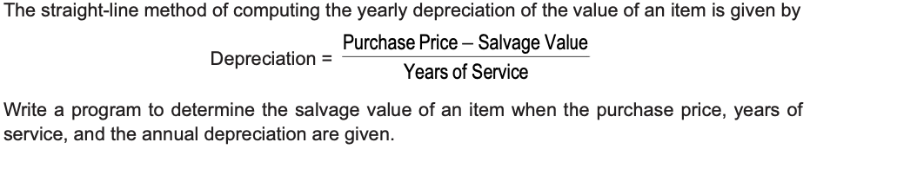

**5.**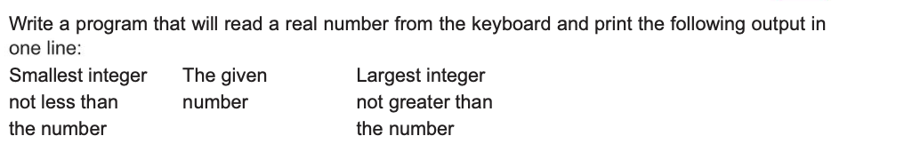

**6. The total distance travelled by a vehicle in t seconds is given by**

**distance = ut + ( a t 2 )/2**

**Where u is the initial velocity (metres per second), a is the acceleration (metres per second 2 ). Write a**

**program to evaluate the distance travelled at regular intervals of time, given the values of u and a . The program should provide the flexibility to the user to select his own time intervals and repeat the calculations for different values of u and a .**

**7. In inventory management, the Economic Order Quantity for a single item is given by**

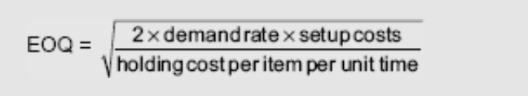

**and the optimal Time Between Orders**

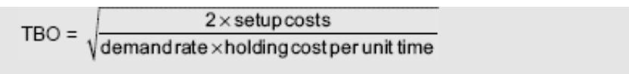

**Write a program to compute EOQ and TBO, given demand rate (items per unit time), setup costs (per order), and the holding cost (per item per unit time).**

**8. For a certain electrical circuit with an inductance L and resistance R, the damped natural frequency is given by**

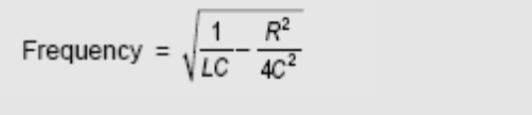

**It is desired to study the variation of this frequency with C (capacitance). Write a program to calculate the frequency for different values of C starting from 0.01 to 0.1 in steps of 0.01.**

**9. Write a program to read a four digit integer and print the sum of its digits.**

**10. Write a program to read a four digit integer and print the sum of its digits.**

**11. Write a program to read two integer values m and n and to decide and print whether m is a multiple of n.**

**12. Write a program to read three values using scanf statement and print the following results:**

**(a) Sum of the values**

**(b) Average of the three values (c) Largest of the three**

**(d) Smallest of the three**

**13. The cost of one type of mobile service is Rs. 250 plus Rs. 1.25 for each call made over and above 100**

**calls. Write a program to read customer codes and calls made and print the bill for each customer.**

**14.**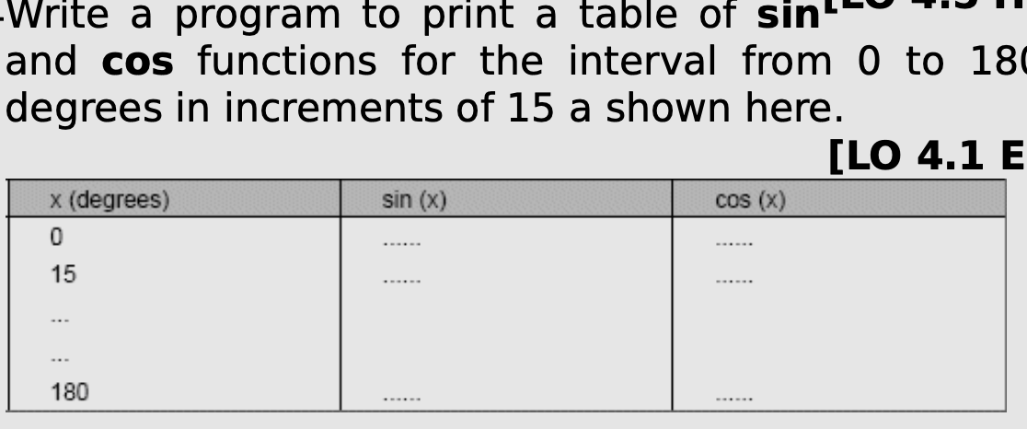

**15. Write a program to compute the values of square- roots and squares of the numbers 0 to 100 in steps 10 and print the output in a tabular form as shown below.**

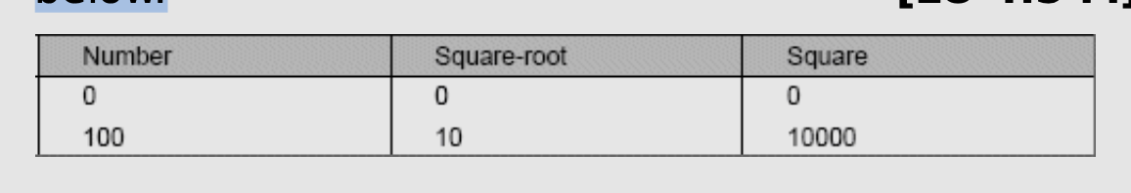

**16. Write a program to illustrate the use of cast operator in a real life situation.**

**17. Write a C program to shift the given data by two bits to the left.**

**18. Write a C program to shift the given data by two bits to the left.**

**19. Write a C program to input a date value and determine whether the entered day, month, and year values are valid.**

**20. Write a C program to input the sides of a triangle and determine whether the triangle is isoceles or not.**

**21. Write a C program that reads two numbers and performs their division. If the division is not**

**possible, then an error messgage, ‘Division not possible’ is displayed.**

**22. Input the value of 4 variables a, b, c and d and compute the resultant value of following expressions: [LO 4.3 M]**

**(a + b) * (c / d) (a + b) * c / d a + (b * c) / d**

**ANSWER:**

1. **Write a program that reads a floating-point number and then displays the right-most digit of the integral part of the number**.

#include <stdio.h>

#include <math.h>

int main() {

float num;

int integralPart;

printf("Enter a floating-point number: ");

scanf("%f", &num);

integralPart = (int)floor(num);

printf("The right-most digit of the integral part is %d\n", integralPart % 10);

return 0;

}



1. **Modify the above program to display the two right- most digits of the integral part of the number.**

#include <stdio.h>

#include <math.h>

int main() {

float num;

int integralPart;

printf("Enter a floating-point number: ");

scanf("%f", &num);

integralPart = (int)floor(num);

printf("The two right-most digits of the integral part are %02d\n", integralPart % 100);

return 0;

}

3. **. Given an integer number, write a program that displays the number as follows:**

**First line : all digits**

**Second line : all except first digit**

**Third line : all except first two digits**

**.......**

**Last line : The last digit**

**For example, the number 5678 will be displayed as:**

**5 6 7 8**

**6 7 8**

**7 8**

**8**

#include <stdio.h>

#include<math.h>

int main() {

int num, temp, digits = 0;

printf("Enter an integer: ");

scanf("%d", &num);

temp = num;

while (temp != 0) {

digits++;

temp /= 10;

}

printf("All digits: ");

for (int i = digits; i >= 1; i--) {

printf("%d ", num / (int) pow(10, i-1) % 10);

}

printf("\n");

printf("All except first digit: ");

for (int i = digits-1; i >= 1; i--) {

printf("%d ", num / (int) pow(10, i-1) % 10);

}

printf("\n");

printf("All except first two digits: ");

for (int i = digits-2; i >= 1; i--) {

printf("%d ", num / (int) pow(10, i-1) % 10);

}

printf("\n");

printf("Last digit: %d\n", num % 10);

}

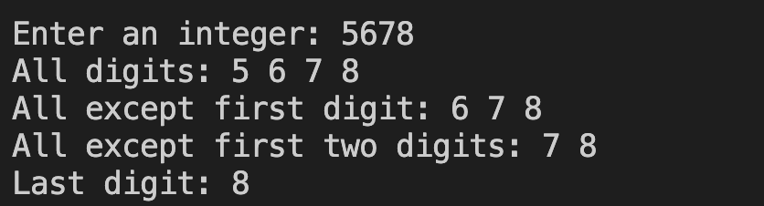

4.

#include <stdio.h>

int main()

{

int purchase_price, service_year, salvage_value, depreciation;

printf("Enter Price of Item: ");

scanf("%d", &purchase_price);

printf("Enter Years of Service: ");

scanf("%d", &service_year);

printf("Enter Annual Depreciation: ");

scanf("%d", &depreciation);

salvage_value = -1*((depreciation *service_year) - purchase_price);

printf("Salvage value Of that Item is : %d\n", salvage_value);

}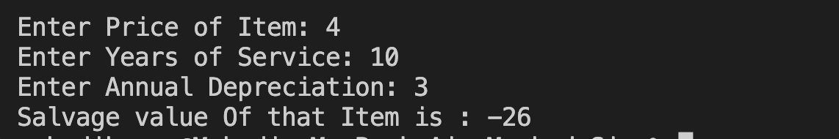

5.

#include <stdio.h>

#include <math.h>

int main()

{

float real_number;

int smallest, largest ;

printf("Enter a Real Number: ");

scanf("%f",&real_number);

printf("Entered Number: %f\n",real_number);

smallest = floor(real_number);

printf("The Smallest Integer: %d\n", smallest);

largest = ceil(real_number);

printf("The Largest Integer: %d\n", largest);

return 0;

}

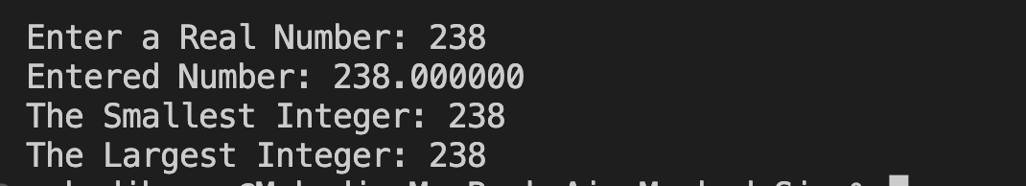

6. **The total distance travelled by a vehicle in t seconds is given by**

**distance = ut + ( a t 2 )/2**

**Where u is the initial velocity (metres per second), a is the acceleration (metres per second 2 ).**

**Write a program to evaluate the distance travelled at regular intervals of time, given the values of u and a . The program should provide the flexibility to the user to select his own time intervals and repeat the calculations for different values of u and a .**

#include <stdio.h>

#include <math.h>

int main()

{

float init_velocity, acceleration, time, distance;

printf("Enter Initial Velocity (u): ");

scanf("%f",&init_velocity);

printf("Enter Acceleration (a): ");

scanf("%f",&acceleration);

printf("Enter Total Time (t): ");

scanf("%f",&time);

distance = (init_velocity * time) + ((acceleration * pow(time,2))/2);

printf("Total Distance Travelled: %0.3f Meters\n", distance);

return 0;

}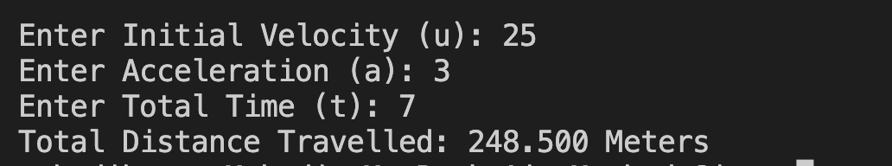

7. **In inventory management, the Economic Order Quantity for a single item is given by**



**and the optimal Time Between Orders**



**Write a program to compute EOQ and TBO, given demand rate (items per unit time), setup costs (per order), and the holding cost (per item per unit time).**

#include <stdio.h>

#include <math.h>

int main()

{

float demand_rate, setup_cost, hcput, EOQ, TBO;

printf("Enter Demand Rate: ");

scanf("%f", &demand_rate);

printf("Enter Setup Cost: ");

scanf("%f", &setup_cost);

printf("Enter Holding Cost Per Unit Time: ");

scanf("%f", &hcput);

EOQ = sqrt((2 * demand_rate * setup_cost)/hcput);

printf("Economic Order Quantity : %0.2f\n", EOQ);

TBO = sqrt((2 * setup_cost)/(hcput * demand_rate));

printf("Time Between Orders : %0.2f\n", TBO);

return 0;

}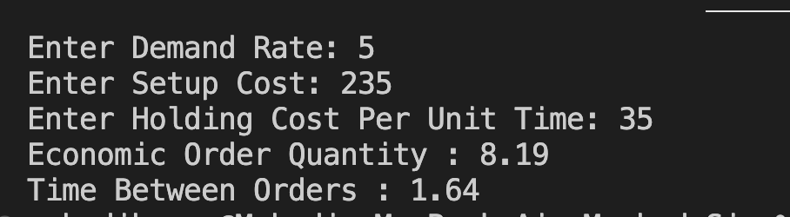

8. **For a certain electrical circuit with an inductance L and resistance R, the damped natural frequency is given by**



**It is desired to study the variation of this frequency with C (capacitance). Write a program to calculate the frequency for different values of C starting from 0.01 to 0.1 in steps of 0.01**

#include <stdio.h>

#include <math.h>

int main()

{

float frequency, resistance, inductance, capacitance = 0.01;

float onebylc, rsqubycsqu,diff_freq;

printf("Enter Circuit Inductance (L): ");

scanf("%f", &inductance);

printf("Enter Circuit Resistance (R): ");

scanf("%f", &resistance);

while(capacitance <= 0.1){

onebylc = 1 / (inductance * capacitance);

rsqubycsqu = pow(resistance, 2)/ 4 * pow(capacitance, 2);

diff_freq = -1*(onebylc - rsqubycsqu);

frequency = sqrt(diff_freq);

printf("Frequency: %f\t @ Capacitance: %f\n",frequency, capacitance);

capacitance +=0.01;

}

return 0;

}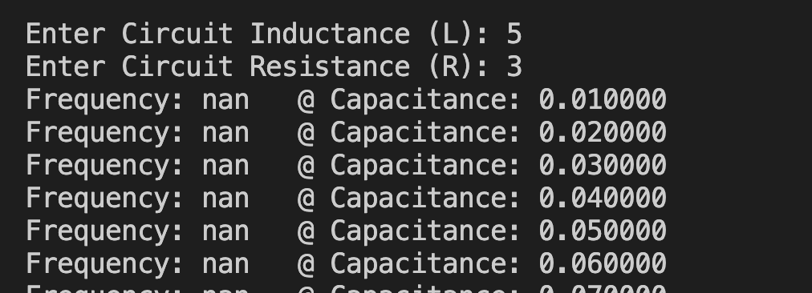

9. **Write a program to read a four digit integer and print the sum of its digits.**

#include <stdio.h>

int main()

{

int number;

int sum = 0;

printf("Enter a Number: ");

scanf("%d", &number);

while(number>0){

sum =sum + number % 10;

number =number / 10;

}

printf("Sum of Digits : %d\n", sum);

return 0;

}

**10. Write a program to read a four digit integer and print the sum of its digits**

#include <stdio.h>

int main()

{

int first, second, third;

printf("Enter Three Numbers: ");

scanf("%d %d %d", &first, & second, &third);

printf("Largest Number is : ");

if(first > second){

if(first > third) printf("%d\n", first);

else printf("%d\n", third);

}

else{

if(second > third) printf("%d\n", second);

else printf("%d\n", third);

}

}

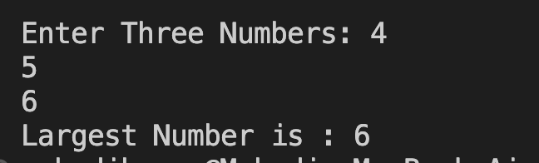

**11. Write a program to read two integer values m and n and to decide and print whether m is a multiple of n**.

#include <stdio.h>

int main()

{

int m, n;

printf("Enter Value of M and N(N>M): ");

scanf("%d %d", &m, &n);

if (n % m == 0)

printf("%d is Multipler of %d", m, n);

else

printf("%d is Not Multipler of %d", m, n);

return 0;

}

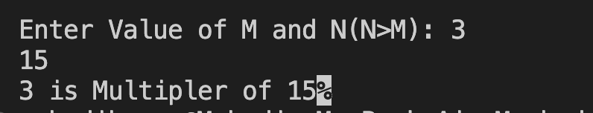

**12. Write a program to read three values using scanf statement and print the following results:**

**(a) Sum of the values**

**(b) Average of the three values (c) Largest of the three**

**(d) Smallest of the three**

#include <stdio.h>

int main() {

int a, b, c;

printf("Enter three values: ");

scanf("%d %d %d", &a, &b, &c);

int sum = a + b + c;

printf("Sum: %d\n", sum);

float average = (float) sum / 3;

printf("Average: %.2f\n", average);

int largest = a;

if (b > largest) {

largest = b;

}

if (c > largest) {

largest = c;

}

printf("Largest: %d\n", largest);

int smallest = a;

if (b < smallest) {

smallest = b;

}

if (c < smallest) {

smallest = c;

}

printf("Smallest: %d\n", smallest);

return 0;

}

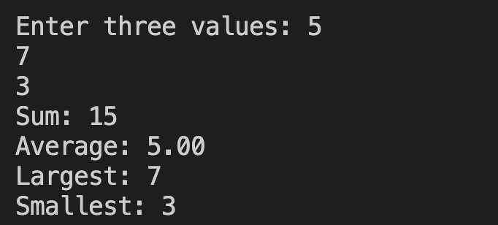

**13. The cost of one type of mobile service is Rs. 250 plus Rs. 1.25 for each call made over and above 100**

**calls. Write a program to read customer codes and calls made and print the bill for each customer.**

#include <stdio.h>

int main() {

int a, b, c;

printf("Enter three values: ");

scanf("%d %d %d", &a, &b, &c);

int sum = a + b + c;

printf("Sum: %d\n", sum);

float average = (float) sum / 3;

printf("Average: %.2f\n", average);

int largest = a;

if (b > largest) {

largest = b;

}

if (c > largest) {

largest = c;

}

printf("Largest: %d\n", largest);

int smallest = a;

if (b < smallest) {

smallest = b;

}

if (c < smallest) {

smallest = c;

}

printf("Smallest: %d\n", smallest);

return 0;

}

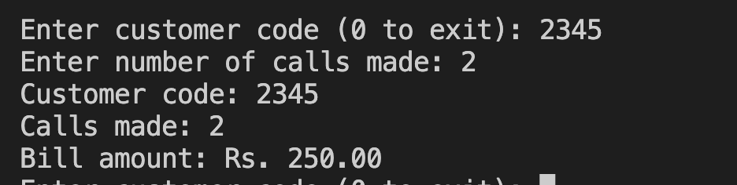  
14.

#include <stdio.h>

#include <math.h>

#define PI 3.14159265

int main() {

int angle;

float radians, sine, cosine;

printf("Angle\tSin\tCos\n");

for (angle = 0; angle <= 180; angle += 15) {

radians = angle * PI / 180;

sine = sin(radians);

cosine = cos(radians);

printf("%d\t%.3f\t%.3f\n", angle, sine, cosine);

}

return 0;

}

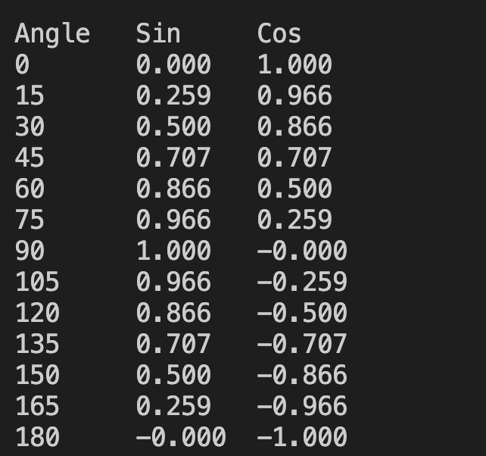

**15. Write a program to compute the values of square- roots and squares of the numbers 0 to 100 in steps 10 and print the output in a tabular form as shown below.**



#include <stdio.h>

#include <math.h>

int main() {

int num;

float sqrt_val, square_val;

printf("Number\tSquare\tSquare Root\n");

for (num = 0; num <= 100; num =num+10)

{

square_val = pow(num, 2);

sqrt_val = sqrt(num);

printf("%d\t%.2f\t%.2f\n", num, square_val, sqrt_val);

}

}

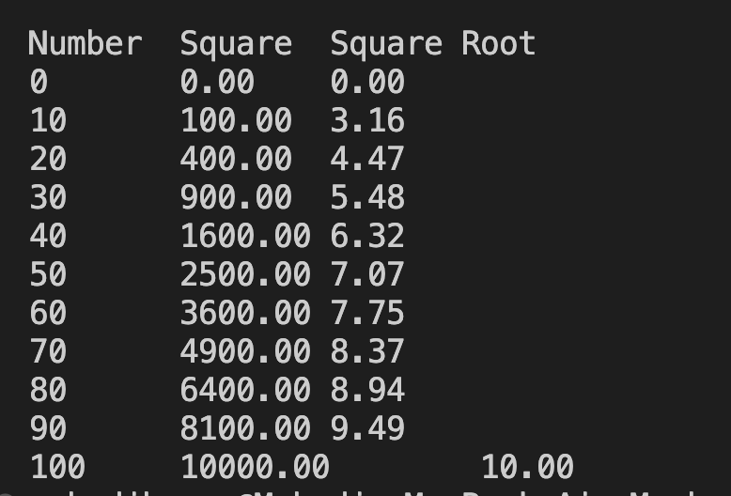

**16. Write a program to illustrate the use of cast operator in a real life situation.**

#include <stdio.h>

int main() {

float meal_cost = 50.0;

int sales_tax_rate = 8;

float sales_tax_amount = meal_cost * (float)sales_tax_rate / 100.0;

float total_cost = meal_cost + sales_tax_amount;

printf("Meal cost: $%.2f\n", meal_cost);

printf("Sales tax rate: %d%%\n", sales_tax_rate);

printf("Sales tax amount: $%.2f\n", sales_tax_amount);

printf("Total cost: $%.2f\n", total_cost);

}

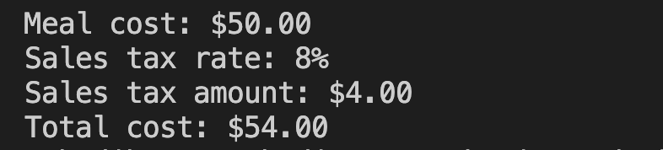

**17. Write a C program to shift the given data by two bits to the left.**

#include <stdio.h>

int main()

{

unsigned int data = 0x7F;

unsigned int shifted_data = data << 2;

printf("Data: 0x%02X\n", data);

printf("Shifted data: 0x%02X\n", shifted_data);

}

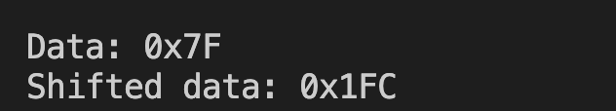

**18. Write a C program to shift the given data by two bits to the left.**

#include <stdio.h>

int main() {

float a, b, c, x;

printf("Enter the values of a, b, and c: ");

scanf("%f %f %f", &a, &b, &c);

x = a - b/3 + c*2 - 1;

printf("x = %f\n", x);

}

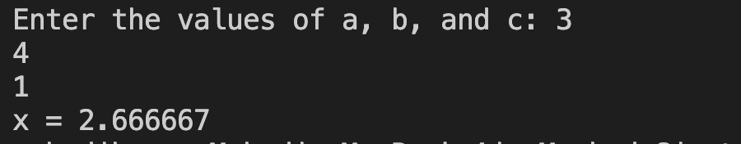

19. **Write a C program to input a date value and determine whether the entered day, month, and year values are valid**.

#include <stdio.h>

int main()

{

int day,days, years, weeks;

printf("Enter the days: ");

scanf("%d",&day);

days = day;

years = days/365;

weeks = (days % 365)/7;

days = days- ((years*365) + (weeks*7));

printf("Years: %d\n", years);

printf("Weeks: %d\n", weeks);

printf("Days: %d \n", days);

return 0;

}

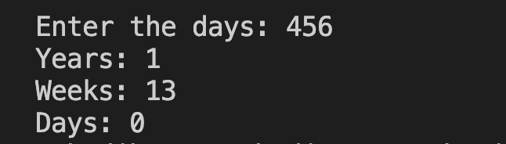

**20. Write a C program to input the sides of a triangle and determine whether the triangle is isoceles or not.**

#include <stdio.h>

int main() {

int a, b, c;

printf("Enter the lengths of the sides of the triangle: ");

scanf("%d %d %d", &a, &b, &c);

if (a == b || b == c || c == a) {

printf("The triangle is isosceles.\n");

}

else

{

printf("The triangle is not isosceles.\n");

}

}

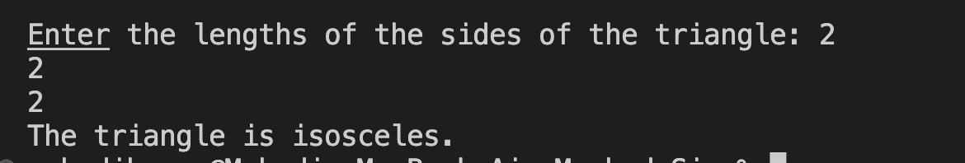

**21. Write a C program that reads two numbers and performs their division. If the division is not**

**possible, then an error messgage, ‘Division not possible’ is displayed.**

#include <stdio.h>

int main() {

float num1, num2, result;

printf("Enter two numbers: ");

scanf("%f %f", &num1, &num2);

if (num2 == 0) {

printf("Division not possible\n");

}

result = num1 / num2;

printf("Result: %.2f\n", result);

}

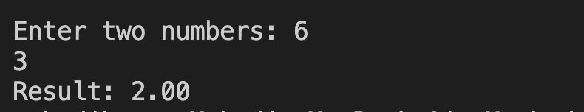

**22. . Input the value of 4 variables a, b, c and d and compute the resultant value of following expressions: [LO 4.3 M]**

**(a + b) * (c / d) (a + b) * c / d a + (b * c) / d**

#include<stdio.h>

int main()

{

float a,b,c,d,x1,x2,x3;

printf("Enter Four Value: ");

scanf("%f%f%f%f",&a,&b,&c,&d);

x1=(a + b) * (c / d);

x2=(a + b) * c / d;

x3=(a + (b * c)/ d);

printf("x1= %f",x1);

printf("x2= %f",x2);

printf("x3= %f",x3);

}

